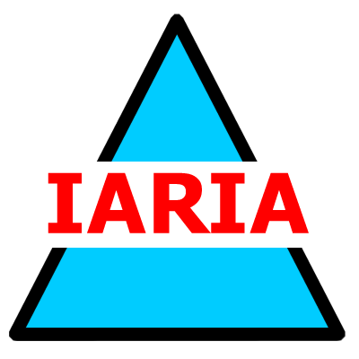  www.iaria.org | The Fourth Advanced International Conference on Telecommunications  AICT 2008  June 8-13, 2008 - Athens, Greece  http://www.iaria.org/conferences2008/AICT08.html

Important deadlines:
Submission deadline January 20, 2008 January 30, 2008
Notification February 25, 2008 February 28, 2008
Registration and camera ready March 15, 2008
Topics:
- Information theory and coding theory
- Communication theory, signal processing, modulation
- Optical communications
- Designing and management of optical networks
- Optical photonic technologies
- Networking theory, protocols, and technologies on next generation networking
- Broadband communications and networks
- Programmable networks, active networks and mobile agents, protocol & standards
- Performance and QoS, Traffic engineering (MPLS, DiffServ, IntServ, etc.)
- Telecommunication/Network management and services
- Broadband access network and service
- Network planning and optimization
- Real-time traffic and QoS
- 3G and 4G mobile communication services
- Wireless communications antennas & propagation & transmission technologies
- Evolution from 2G to 2.5G, 3G and beyond
- Personal communications
- Wireless multimedia & networks & systems
- Cellular and ad hoc networks
- Metro/Access networks
- Wireless access (WPAN, WLAN, WLL)
- Standardization (IEEE 802.15, IEEE 802.16)
- Web services communications, applications, and performance
- Security and trust in Web Services applications
- Platforms for Web Services based applications and services
- Communication software and intelligent network theory
- Object and component technologies in telecommunication software
- Telecommunication protocol engineering and telecommunication software tools
- Standardization (IEEE 802.17, Policy Models, etc.)
- SOHO (Small Offices/Home Offices
- Partial and intermittent resources
- E-learning and mobile learning on telecommunications
- Teletraffic modeling and management

