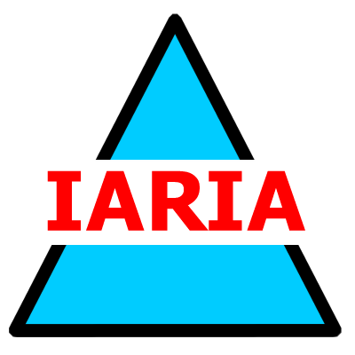  www.iaria.org | The Third International Conference on Internet and Web Applications and Services  ICIW 2008  June 8-13, 2008 - Athens, Greece  http://www.iaria.org/conferences2008/ICIW08.html | Conference Title  CONF  Dates and Location  url

Important deadlines:
Submission deadline January 20, 2008 January 30, 2008
Notification February 25, 2008 February 28, 2008
Registration and camera ready March 15, 2008

Tracks:
- IWAS: Internet and Web-based Applications and Services
- WSSA: Web Services-based Systems and Applications
- ENSYS: Entertainment Systems
- P2PSA: P2P Systems and Applications
- ONLINE: Online Communications, Collaborative Systems, and Social Networks

