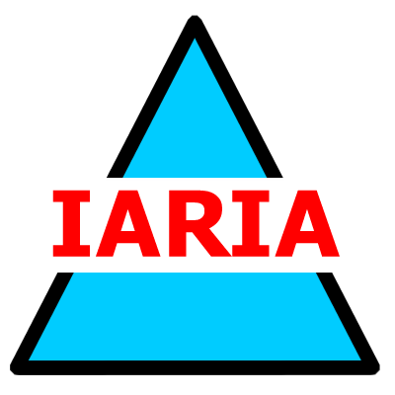  www.iaria.org | International Workshop on Social and Legal Aspects under Emerging Computing Environments  SLAECE 2008  June 8-13, 2008 - Athens, Greece  http://www.iaria.org/conferences2008/SLAECE.html

Important deadlines:
Submission deadline January 20, 2008 January 30, 2008
Notification February 25, 2008 February 28, 2008
Registration and camera ready March 15, 2008

Topics
- Service-oriented Architecture (SOA) and service computing
- Mobile, pervasive, and ubiquitous computing
- Web security and privacy
- Semantic Web and Semantic Web Services
- Agent and autonomous computing
- Grid computing
- Virtual communities
- Inter-, intra-organizational and governmental integration

Topics of legal and social aspects of information systems include but are not limited to:
- Principles, theories, and challenges of legal and social aspects
- Strategies, modeling, and requirements engineering of legal and social aspects
- Architectures, implementations, and deployment consideration of legal and social aspects
- Cyber threats, emerging risks, systemic concerns, and emergency preparedness
- Social computing and lifestyle computing
- Service marketing and customer relationship management
- Market structures and emerging business models
- Emerging legal issues due to new computing environment
- File / information sharing networks and user behavior
- Knowledge modeling, management, and application
- Negotiation and contracting as well as contract monitoring and enforcement
- E-democracy, e-policy, and governance
- Legal and social ontologies
- Privacy and copyright in collaborative environments and social networks
- Intellectual property rights
- Trust, security, and privacy
- Identity management and access control
- Security and Privacy in Location Based services

