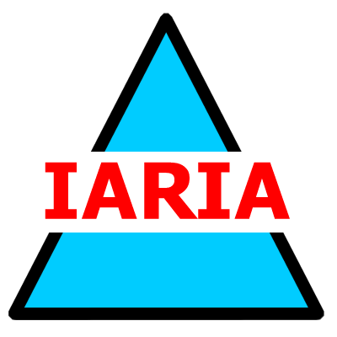  www.iaria.org | First International Workshop on Virtual Environments and Web Applications for e-Learning  VEWAeL 2008  June 8-13, 2008 - Athens, Greece  http://www.iaria.org/conferences2008/VEWAeL.html

Important deadlines:
Submission deadline January 20, 2008 January 30, 2008
Notification February 25, 2008 February 28, 2008
Registration and camera ready March 15, 2008

Topics
- E-Learning
- Web Technologies and Tools for Educational Purposes
- Services for E-Learning Platforms
- Virtual Learning Environments (VLE)
- Course Management Systems
- Web applications for Teaching
- Social Implications of E-Learning
- Lifelong E-learning
- Teaching-Learning Experiences using the Internet for Educational Purposes
- E-learning in the European Higher Education Area (EHEA) and other HE contexts
- Web protocols for VLE
- Security for VLE
- QoS for VLE
- Storage management in VLE

