AICT 2008

The Fourth Advanced International Conference on Telecommunications

http://www.iaria.org/conferences2008/AICT08.html
ICIW 2008

The Third International Conference on Internet and Web Applications and Services

http://www.iaria.org/conferences2008/ICIW08.html
SLAECE 2008

International Workshop on Social and Legal Aspects under Emerging Computing Environments

http://www.iaria.org/conferences2008/SLAECE.html
VEWAeL 2008

International Workshop on Virtual Environments and Web Applications for e-Learning

http://www.iaria.org/conferences2008/VEWAeL.html
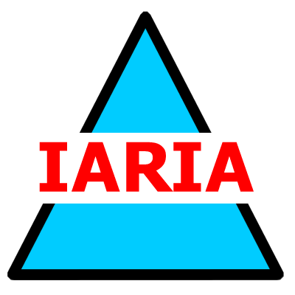  www.iaria.org | June 8-13, 2008 - Athens, Greece  Submission date: January 20, 2008

