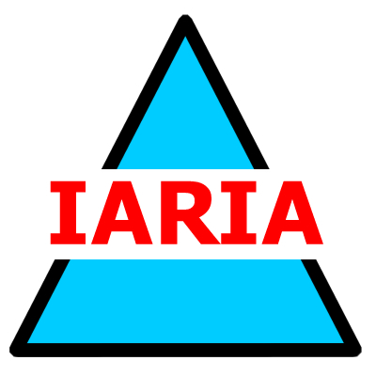

GALA DINNER

Tuesday, November 19th at 20:30
have your badge and your ticket

WELCOME COCKTAIL

Sunday, November 17th from 18:30 to 20:00
have your badge

