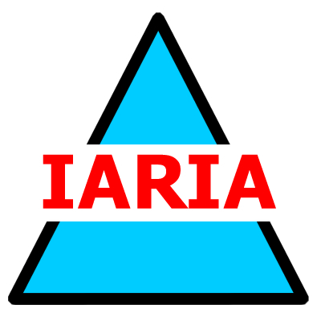

Sunday, November 17

KEYNOTE SPEAKER
15:00 - 16:00

Artificial Intelligence for Precision Agriculture

Speaker
Prof. Dr. Jaime Lloret
Universitat Politècnica de València, Spain
Chair
Petre Dini

Monday, November 18

KEYNOTE SPEAKER
09:00 - 10:00

Needs and Challenges for the Modernization and Technification of a More Sustainable Agriculture

Speaker
Prof. Dr. Sandra Sendra
Universitat Politècnica de València, Spain

Chair
Antonella Di Fonzo

Tuesday, November 19

KEYNOTE SPEAKER
09:00 - 10:00

Innovative Low-Water Turfgrass Management for Sustainable Urban Green Spaces

Speaker
Assist. Prof. Dr. Lorena Parra
Universidad Politécnica de Madrid, Spain
Chair
Pedro Gonçalves

Wednesday, November 20

KEYNOTE SPEAKER
09:00 - 10:00

Impact Perspectives of Smart Farming Research
Speaker
Prof. Dr. Pedro Gonçalves
Escola Superior de Tecnologia e Gestão de Águeda and Instituto de Telecomunicações, Portugal

Chair
Mahdi Abdelguerfi

