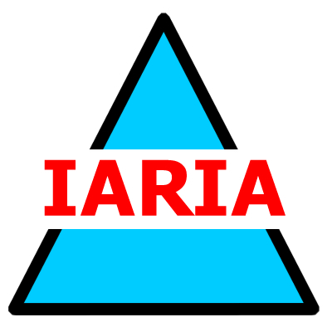

Monday, November 18
18:00 – 19:45

PANEL #1
Challenges in Environmental Sustainability

Moderator:
Prof. Dr. Sandra Sendra, Universitat Politècnica de València, Spain

Panelists
Assist. Prof. Dr. Lorena Parra, Universidad Politécnica de Madrid, Spain
Dr. Mahmood Ahmad, RIZQ/YUNUS WEFnex Hub AIT, Thailand
Ph.D. Candidate Francisco Javier Diaz, Universitat Politècnica de València, Spain
Prof. Dr. Petre Dini. IARIA. USA/EU

Tuesday, November 19
18:30 – 20:15
PANEL #2

Advances in Accessible Digital Agriculture Technologies

Moderator:
Dr. Izar Azpiroz, Fundacion Vicomtech, Spain
Panelists:
Prof. Dr. Sandra Sendra, Universitat Politècnica de València, Spain
Dr. Mahmood Ahmad, RIZQ/YUNUS WEFnex Hub AIT, Thailand
Dr. Laura García, Universidad Politécnica de Cartagena, Spain
Prof. Dr. Petre Dini. IARIA. USA/EU

Wednesday, November 20
16:45 – 18:15

PANEL #3
AI Tools and Sensing in Regenerative Farming

Moderator:
Assist. Prof. Dr. Lorena Parra, Universidad Politécnica de Madrid, Spain
Panelists:
Prof. Dr. Pedro Gonçalves, Escola Superior de Tecnologia e Gestão de Águeda and Instituto de Telecomunicações, Portugal
Ph.D. Candidate Alberto Mino Calero, NTNU, Norway
Dr. Mahmood Ahmad, RIZQ/YUNUS WEFnex Hub AIT, Thailand
Prof. Dr. Petre Dini, IARIA, USA/EU

Wednesday, November 20
18:30 – 20:00

Open Ad Hoc Discussion #1
Theme: Impact of AI-based solutions on Societal Well-being

Moderators:
Dr. Isidoros Perikos, University of Patras, Greece
Prof. Dr. Petre Dini, IARIA USA/EU

Thursday, November 21
09:00 – 10:30

Open Ad Hoc Discussion #2
Theme: Climate, Agriculture, and Technologies

Moderators:
Prof. Dr. Jaime Lloret, Universitat Politècnica de València, Spain
Prof. Dr. Pedro Gonçalves, Escola Superior de Tecnologia e Gestão de Águeda and Instituto de Telecomunicações, Portugal
Dr. Mahmood Ahmad, RIZQ/YUNUS WEFnex Hub AIT, Thailand
Prof. Dr. Petre Dini, IARIA USA/EU

