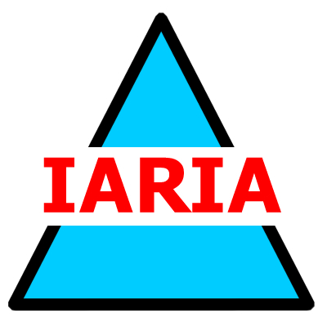

Tutorial #1

Where Should/Could AI be Used and Where it Should/Could not be Used

Speaker:
Prof. Dr. Petre Dini
IARIA, USA/EU

Chair:
Jaime Lloret
Sunday, November 17
13:45 - 14:45
Attendance is free, everyone is welcome!

Tutorial #2

Advances in Machine Learning and Artificial Intelligence: Applications to Agriculture

Speaker:
Dr. Nuria Ortigosa
Universitat Politècnica de València, Spain

Chair:
Jaime Lloret
Sunday, November 17
16:15 - 18:00
Attendance is free, everyone is welcome!

Tutorial + Demo

Running Hydraulics Simulations at Scale Using Inductiva Python API

Speaker:
Dipl. Ing. Paulo Barbosa
Inductiva Research Labs, Portugal

Chair:
Kabid Hassan Shibly
Monday, November 18
16:45 - 17:45
Attendance is free, everyone is welcome!

Tutorial + Demo

Running Hydraulics Simulations at Scale Using Inductiva Python API

Speaker:
Dipl. Ing. Paulo Barbosa
Inductiva Research Labs, Portugal

Chair:
Lorena Parra
Tuesday, November 19
16:45 - 18:15
Attendance is free, everyone is welcome!

